EXPERIMENT 7
Name: Karthik V
Roll No: 240701234
Design an application layout using different colors, text styles, and visual elements. Share the design with users through a Google Form or any other feedback collection method to gather their responses. Based on the feedback received, refine and improve the design accordingly.

- Initially I have designed a application layout using different colors and visual elements.
- After that i have shared it to the users and asked for feedback
- Based on the Feedback I have improved the design

Screen 1:
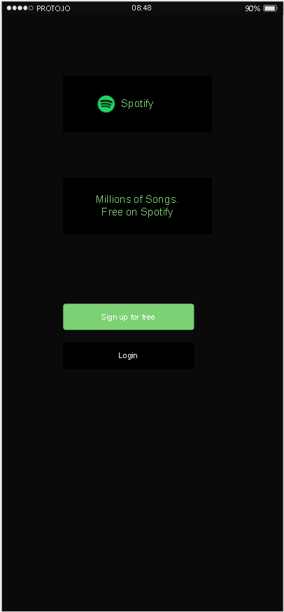
This is the Login page screen I have used some colours, texts,buttons etc.

Screen 2:
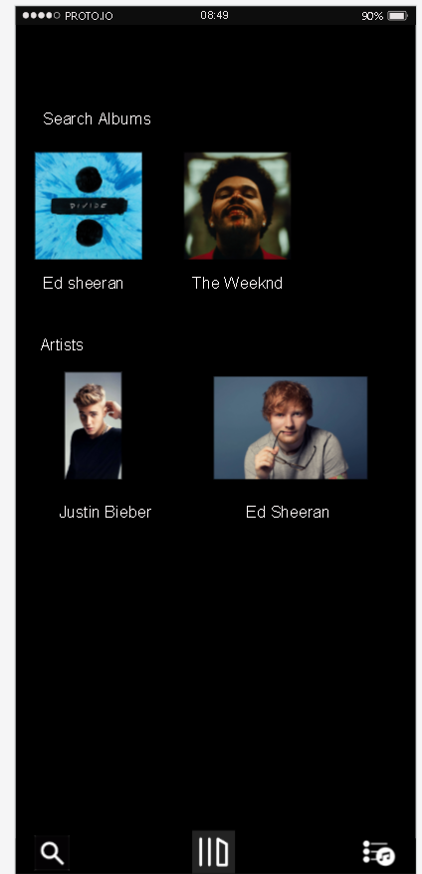
This is the music discovery screen
After this I have created a google form and sent it to the users

Feedback From The User For HomeScreen:
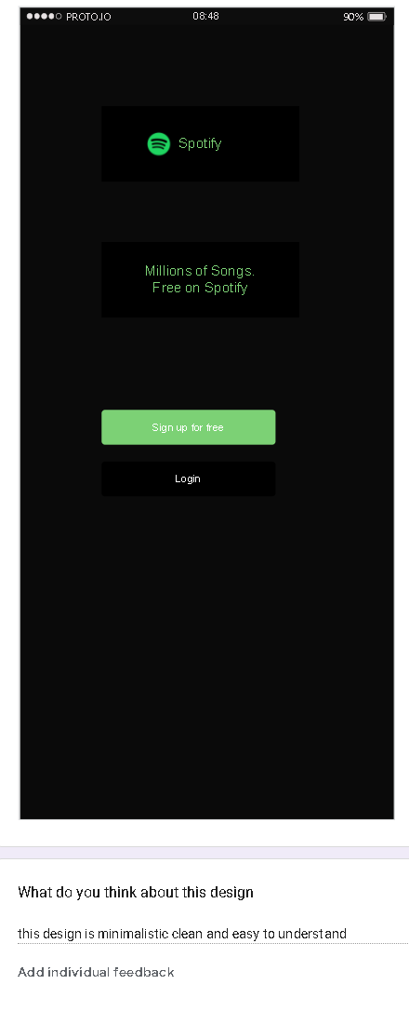

Feedback From The User For Music Directory Screen:
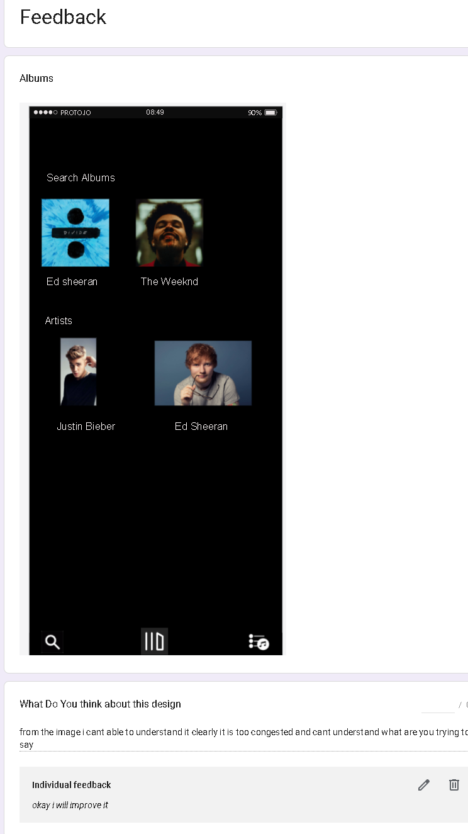
Here the user have suggested some tips for improving the design

Improved Design:
